Laboratory Work 3: Data Manipulation Language (DML)
Subject: Database Management Systems
Topic: DML Operations in PostgreSQL

1. Objective
The objective of this laboratory work is to gain practical experience with Data Manipulation Language (DML) in PostgreSQL, including data insertion (INSERT), updating (UPDATE), deletion (DELETE), and status/conditional manipulation (RETURNING, EXTRACT, string/datetime functions).

2. Tasks & Execution

Task 1: Generate and insert 200 random rows in the airport database
SQL Query
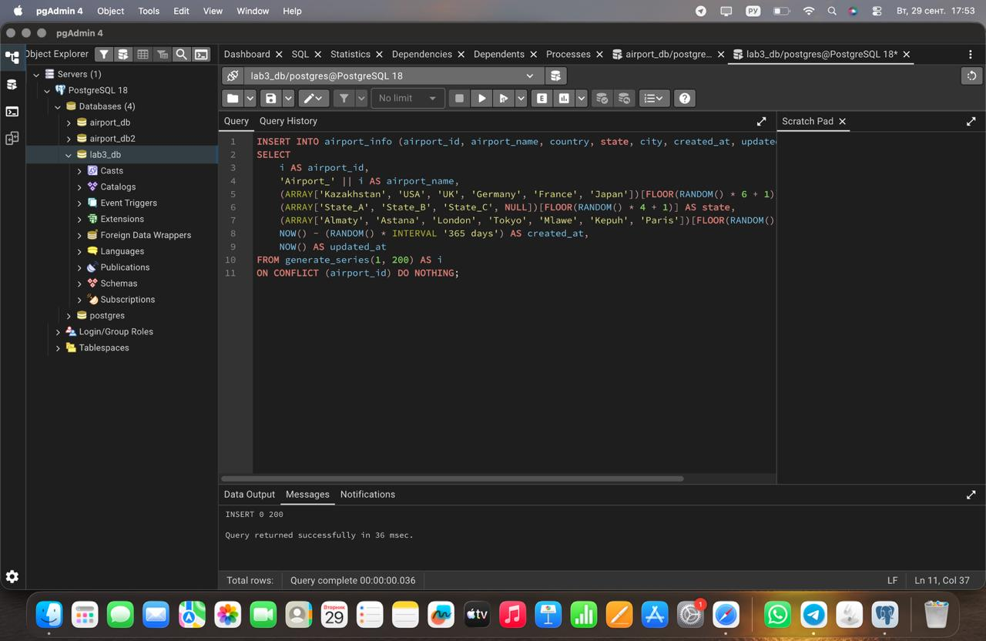

Task 2: Add a new airline named "KazAir" based in "Kazakhstan" to the airline table
SQL Query:

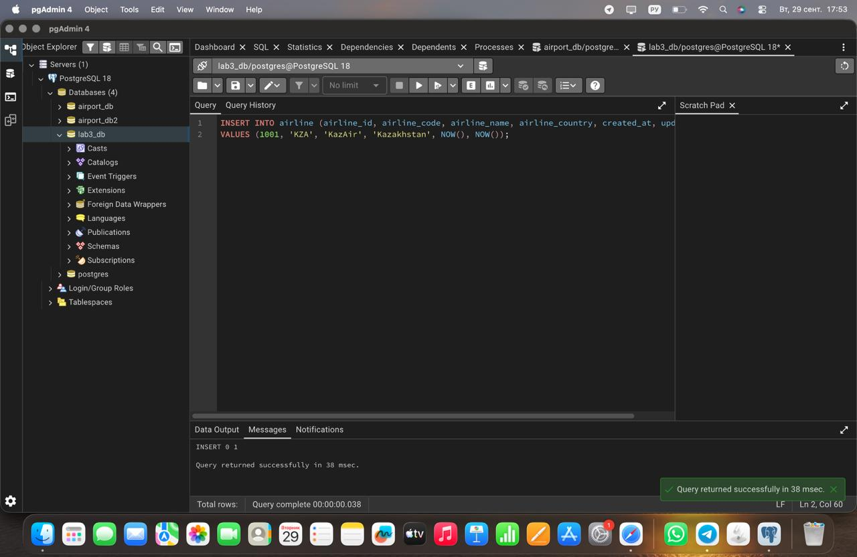

Task 3: Update the airline country "KazAir" to "Turkey"
SQL Query:
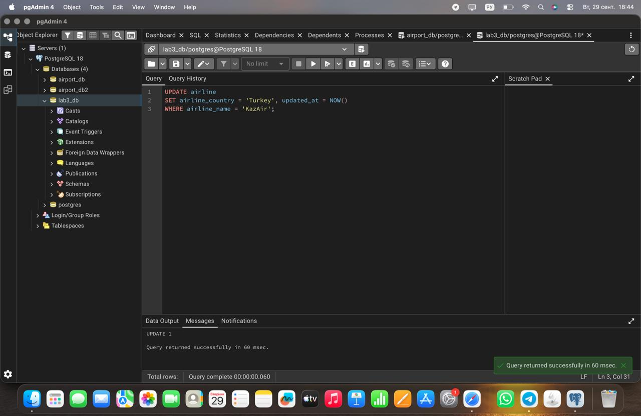

Task 4: Add three airlines at once: "AirEasy" in "France", "FlyHigh" in "Brazil" and "FlyFly" in "Poland"
SQL Query: 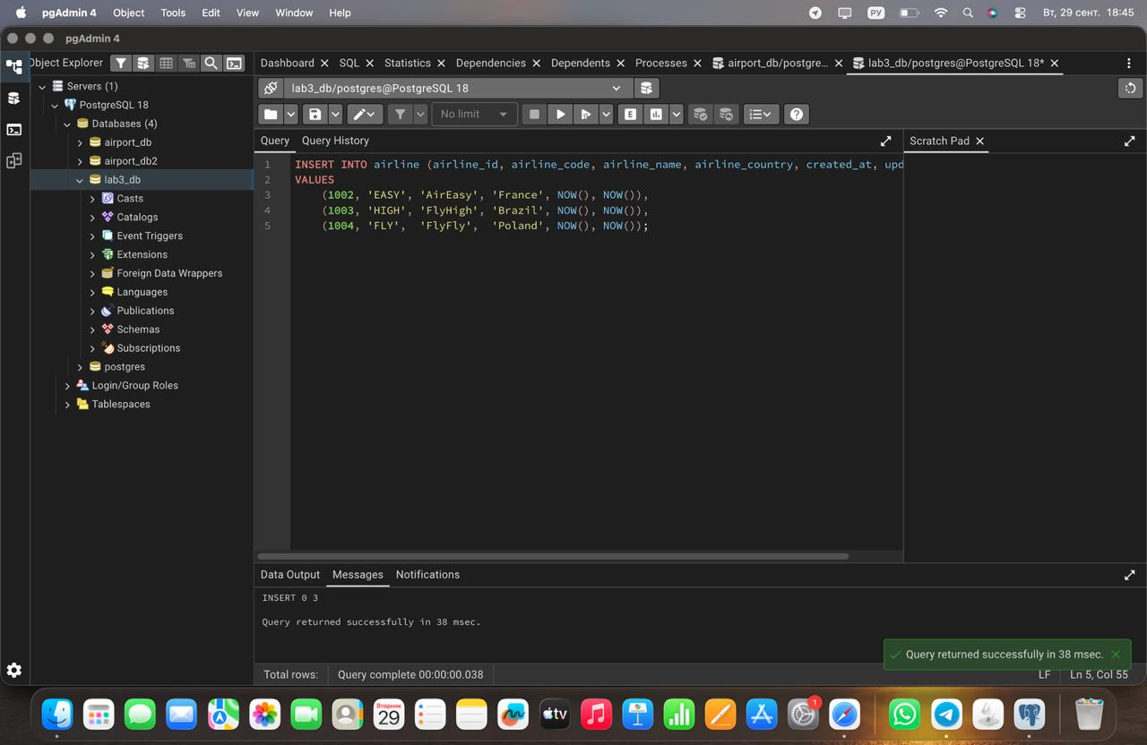

Task 5: Delete all flights whose arrival is in 2024 year
SQL Query: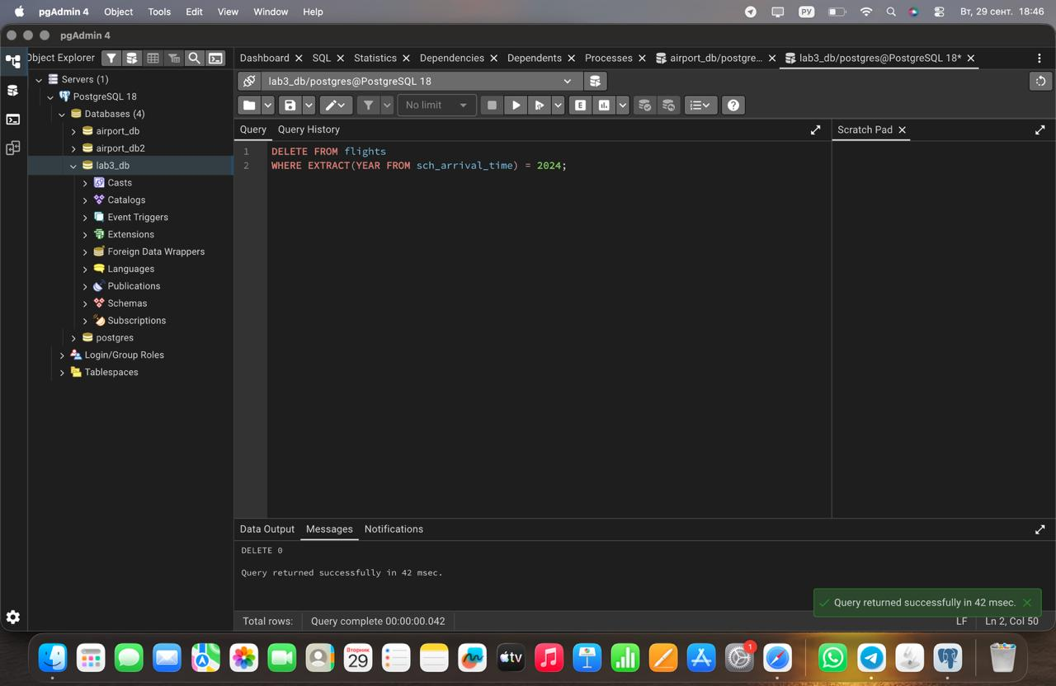

Task 6: Increase the price of all tickets in booking table for flights by 15%
SQ L Query: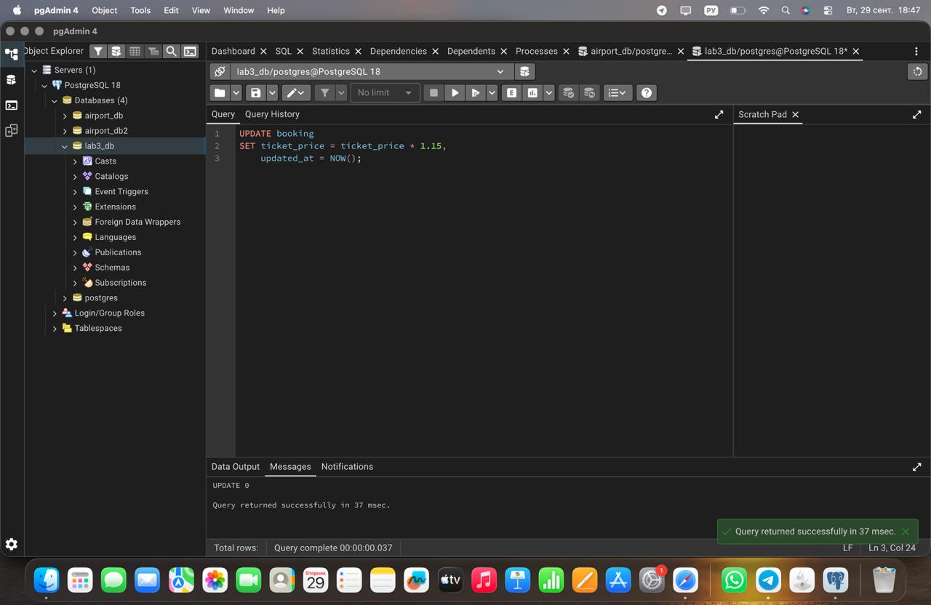

Task 7: Delete all tickets where price is less than 10000
SQL Query:
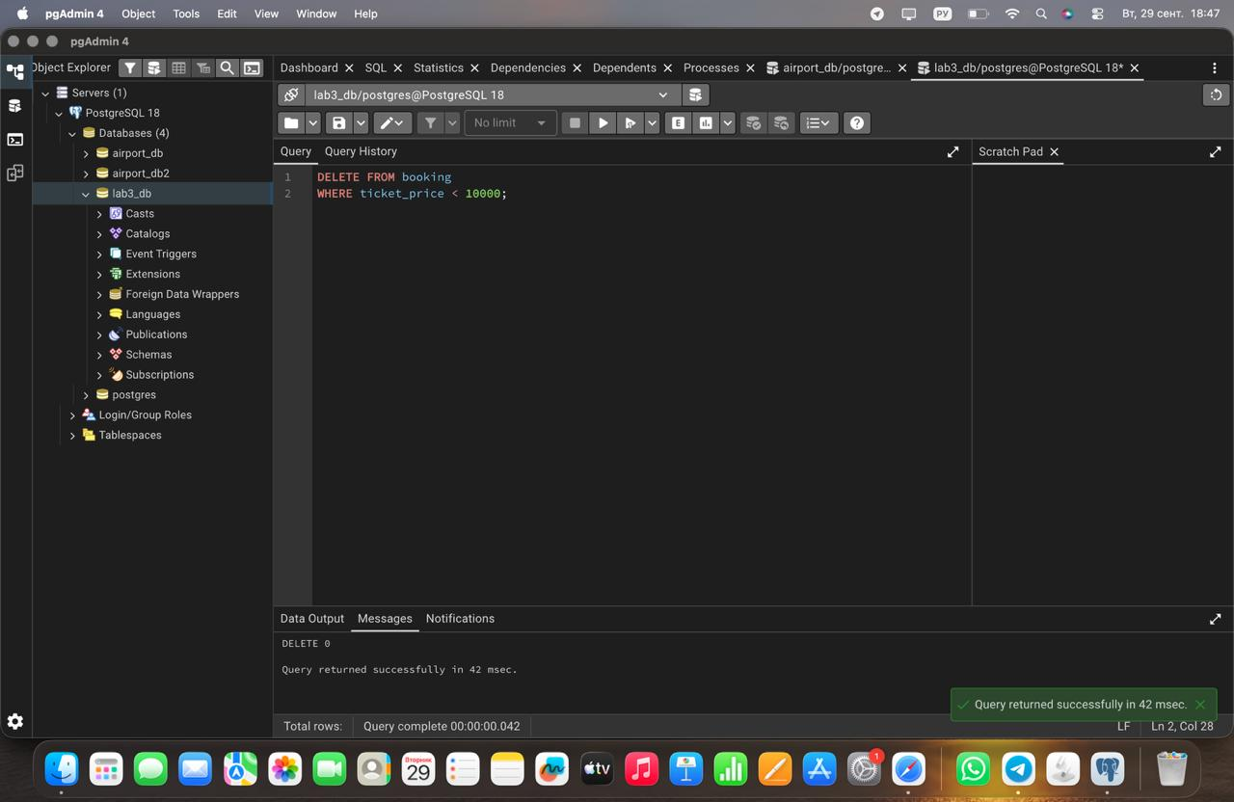

Task 8: Set a default code 'UNK' (Unknown) for any airline in the airline table where airline_code is missing (NULL)
SQL Query:
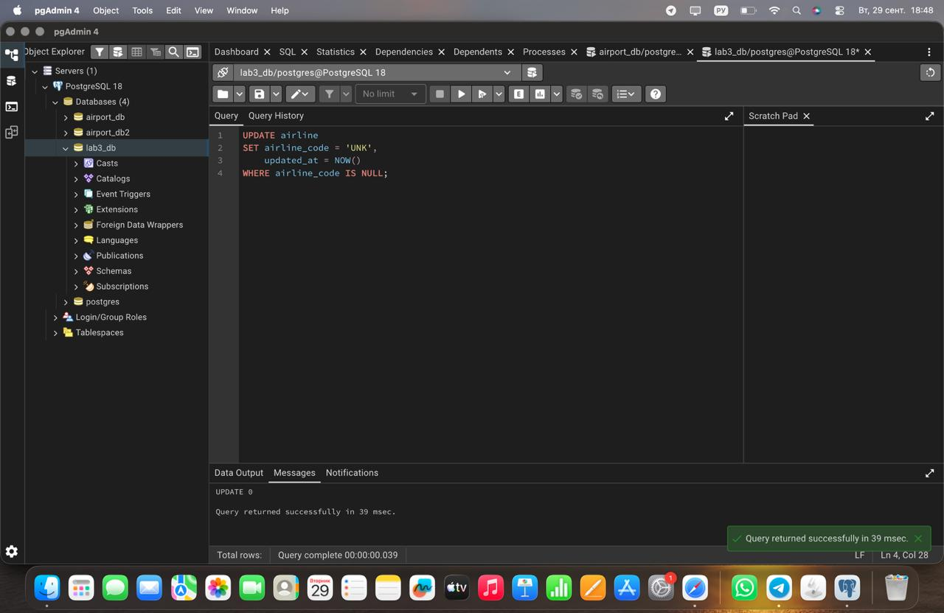

Task 9: Delete all baggage check records created before June 1, 2023, whose result is still 'Not checked'
SQL Query: 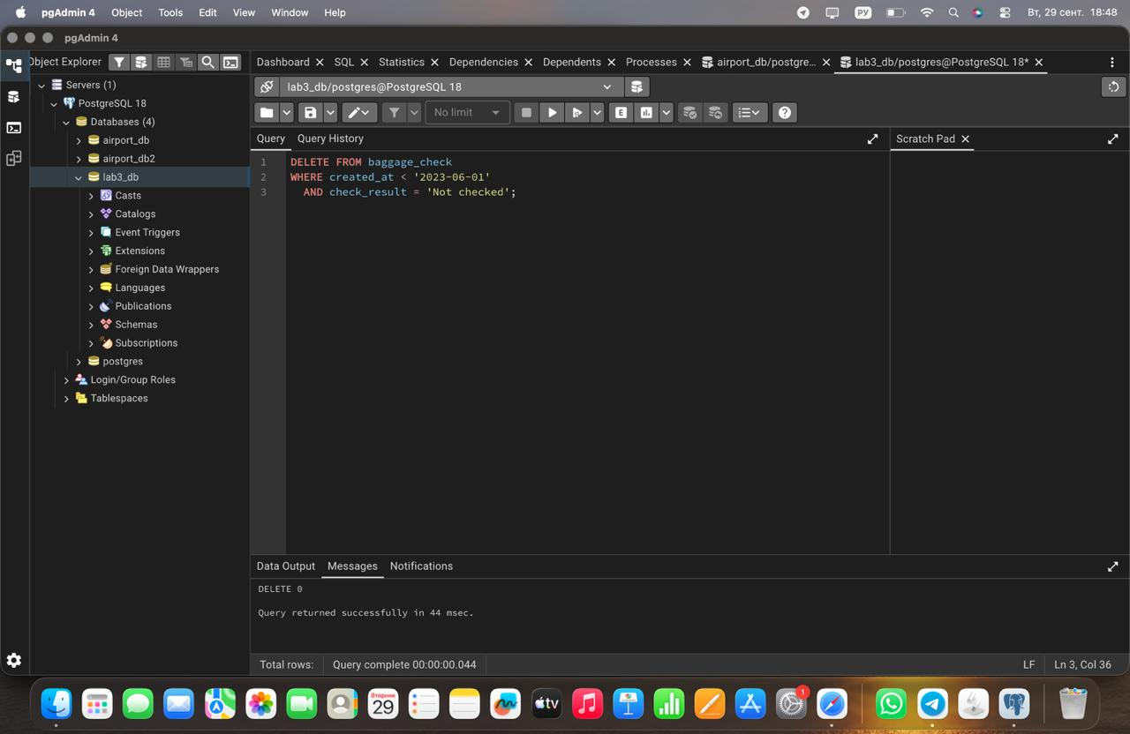

Task 10: Delete all entries from the airport table where state is missing (NULL) and the city is either 'Mlawe' or 'Kepuh'
SQL Query:
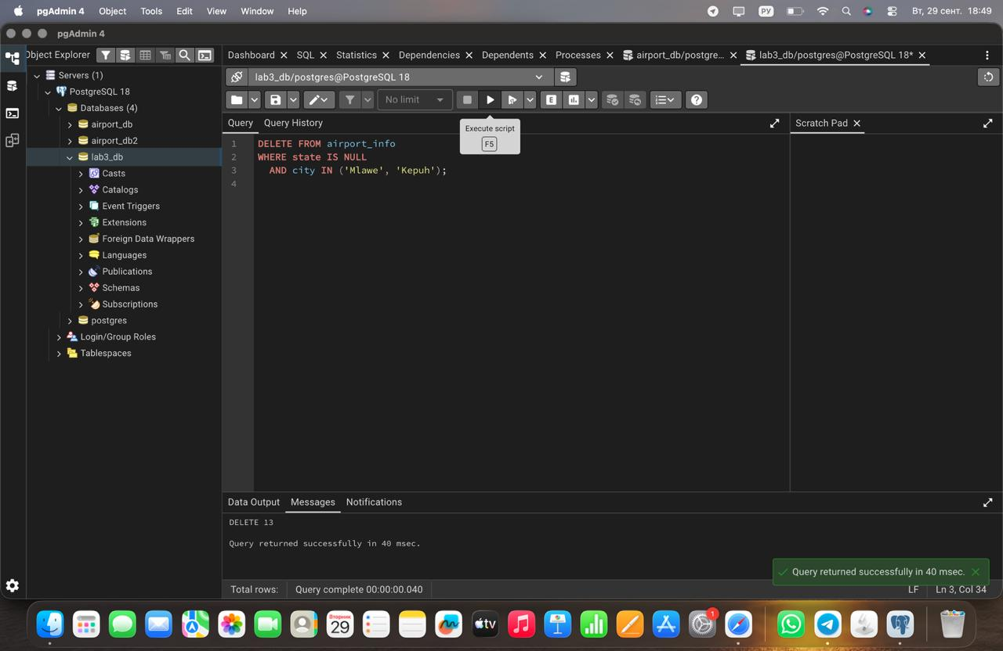

Task 11: Insert a new unchecked baggage inspection record and immediately return its newly generated baggage_check_id and created_at timestamp
SQL Query: 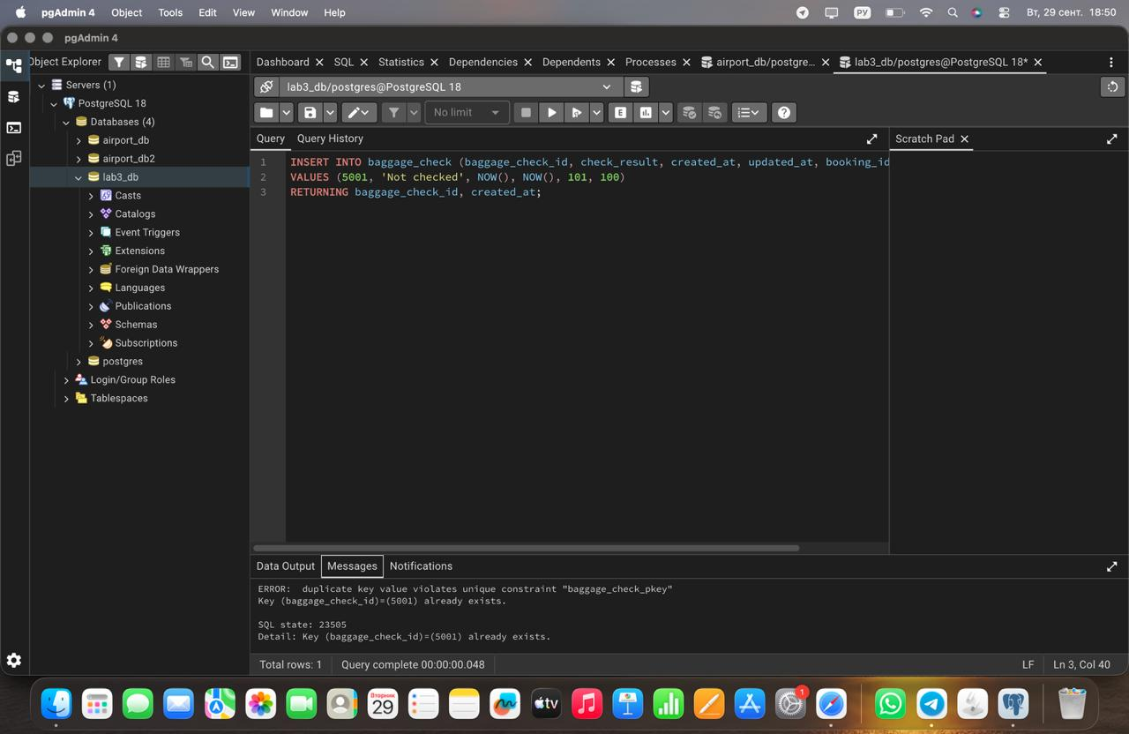

Task 12: Convert all country names in the airline table to uppercase to ensure data consistency
SQL Query: 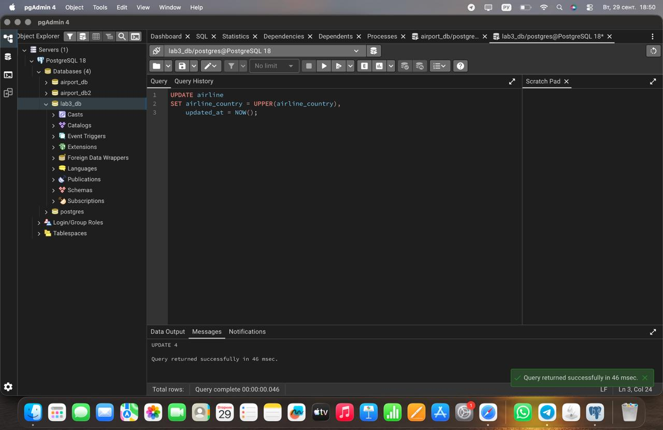

Task 13: Update both the name and country for the airline with airline_id = 5. Set the name to 'Global Airways' and the country to 'United Kingdom', while updating updated_at to the current date
SQL Query: 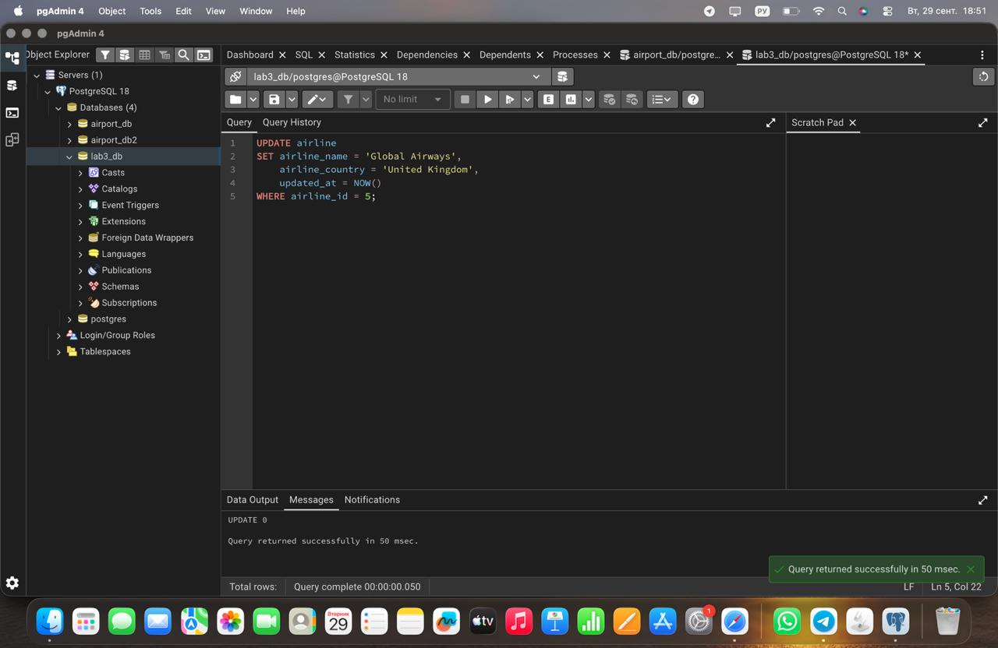

Task 14: Set the state field to 'Capital District' for airports located in specific cities: 'Astana', 'London', and 'Tokyo'
SQL Query: 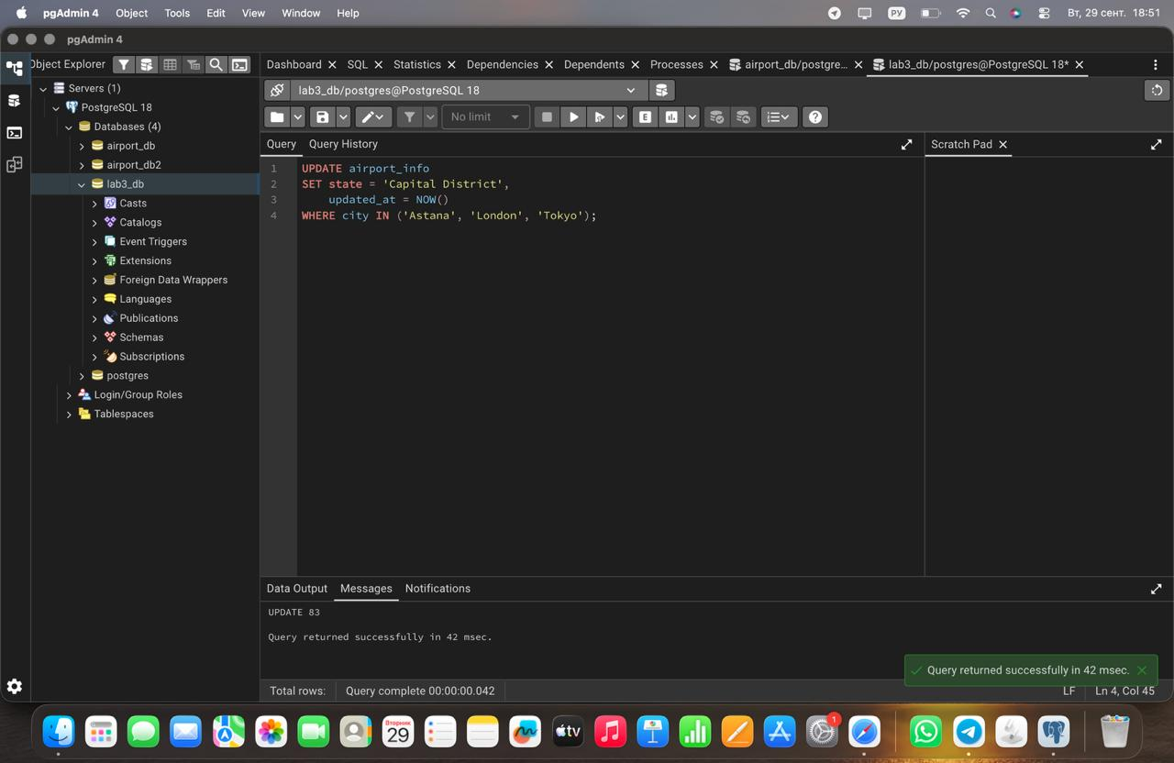

Task 15: Mark all baggage check records (baggage_check) created in March 2024 with a status of 'Not checked' as completed ('Checked')
SQL Query: 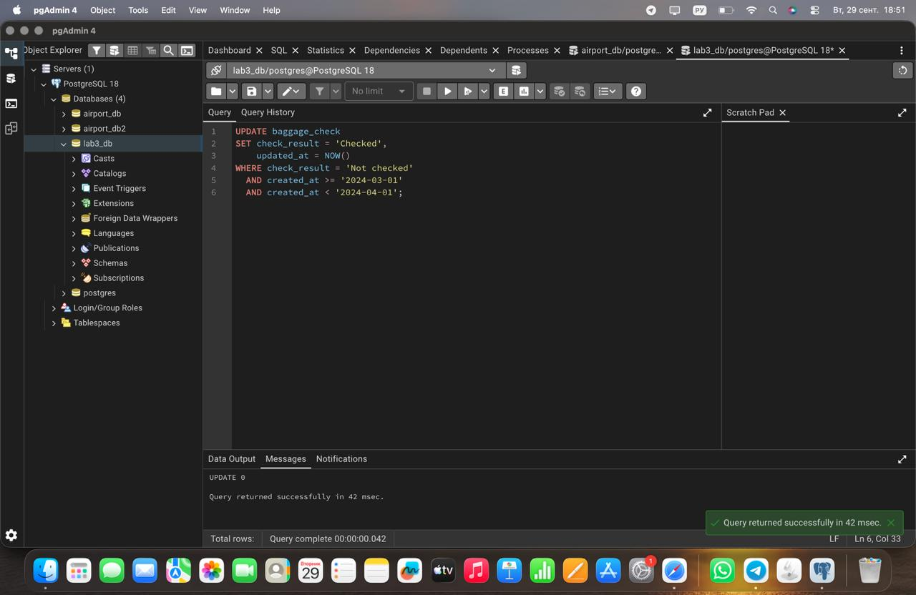

3. Conclusion
In this laboratory work, various DML operations (INSERT, UPDATE, DELETE) were implemented in PostgreSQL. Data manipulation tasks included bulk data generation using generate_series, multi-row insertion, string transformations (UPPER), date manipulations (EXTRACT), and conditional record modifications.

